IMPACT 2025 Sponsorship Package

Since its inception in 2006, the IMPACT Conference has been at the forefront of technological evolution, fostering innovation in the packaging, PCB, and semiconductor industries. Over the past two decades, IMPACT has not only witnessed but actively contributed to rapid advancements in 5G, AI, high-performance computing (HPC), edge computing, and sustainability. Each year, the conference has adapted to the latest trends, driving forward the conversation on emerging technologies and their industrial applications.
Now in its 20th year, IMPACT 2025 embraces the theme “Energy-Efficient AI: From Cloud to the Edge,” reflecting the industry’s growing emphasis on high-performance, low-power solutions. As AI applications continue to expand—from data centers to edge devices—the need for advanced PCB, IC substrates, heterogeneous integration, and packaging technologies has become increasingly critical.
This milestone year marks not just a celebration of the past 20 years, but a bold step into the future, where IMPACT continues to lead, inspire, and drive innovation. Join us at IMPACT 2025 as we shape the next era of AI, semiconductor packaging, and PCB technology—powering a smarter, more sustainable world.
As a sponsor, your company will enjoy exclusive access to cutting-edge research and the opportunity to showcase your innovative products and solutions to key decision-makers. Additional benefits include company promotion and the chance to elevate your company's reputation. We cordially invite you to join us as a valued supporter.


Sincerely,

Shih-Chieh Chang, Ph.D., General Chair of IMPACT 2025
General Director, Electronic and Optoelectronic System Research Laboratories (EOSL), ITRI

【IMPACT 2025】

【Date】Oct. 21st (Tue.)-24th (Fri), 2025【Venue】Taipei Nangang Exhibition Center
【Theme】Energy efficient AI: From Cloud to the Edge
【Organizer】IEEE-EPS、iMAPS Taiwan、ITRI、TPCA
【Exhibition】TPCA Show, TAITRONICS, AIoT Taiwan
【Official Website】www.impact.org.tw
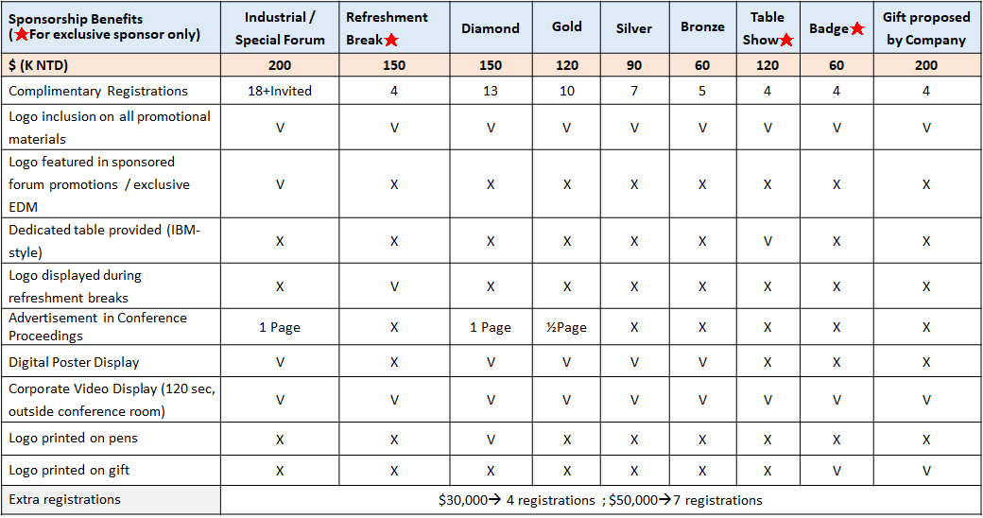
【Sponsorship Package】 ★Exclusively

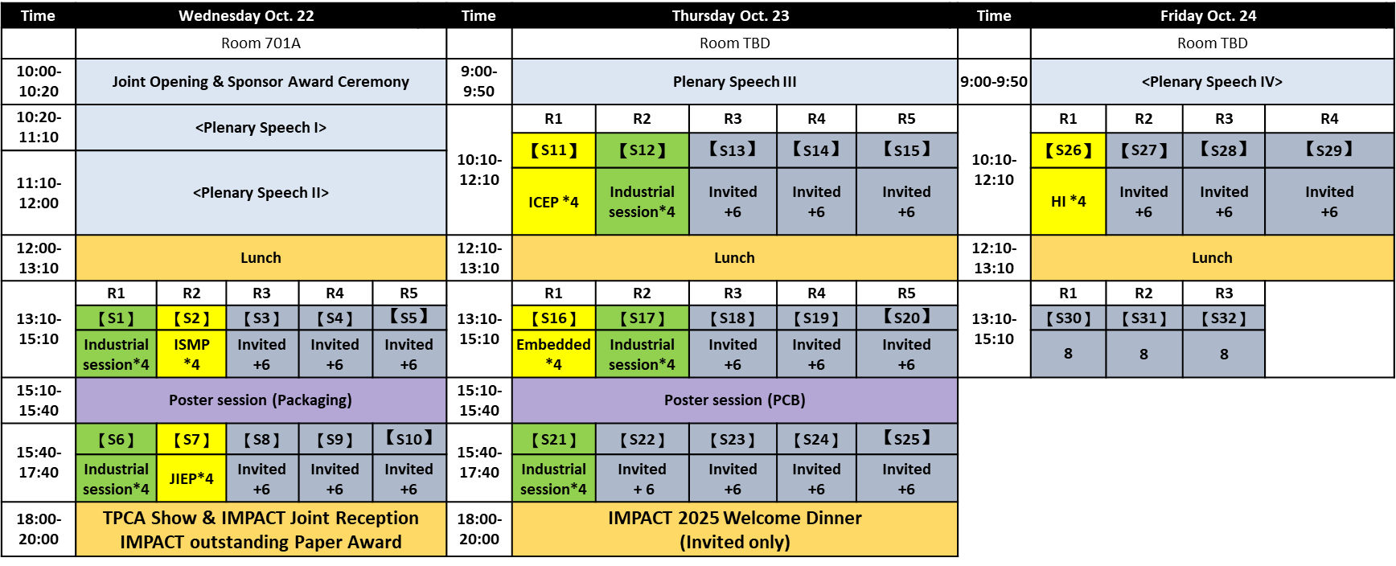
IMPACT 2025 Agenda (TBD)

Sponsorship Package
Company Profile
Company Name
Contact Person |  |  | Job Title
Phone/ext. |  |  | Fax
E-Mail |  |  | Business No
Address |  |  | Webpage
Company Logo | Please email your Logo to service@impact.org.tw
Honored Advisor as a representative in IMPACT 2025 |  | Name
 |  | Job Title
 |  | E-Mail

SPONSORSHIP：Please your preferred sponsorship
Sponsorship | Sponsor Fee  (K NTD) | Free Registrants
Industrial Forum | - $200 | 18+Invited Speakers
Special Forum  Topic: | - $200 | 18+Invited Speakers
Refreshment Break (Exclusively) | - $150 | 4
Diamond | - $150 | 13
Gold | - $ 120 | 10
Silver | - $ 90 | 7
Bronze | - $ 60 | 5
Table Show (Exclusively) | - $120 | 4
Badge (Exclusively) | - $60 | 4
Gift proposed by Sponsor | - $ 200 | 4
Extra Registrations | - $ 30 | 4
Extra Registrations | - $ 50 | 7

Payment details
Account Name | Taiwan Printed Circuit Association | IMPACT Secretariat Address | No 147, Sec 2, Gaotie N Rd, Dayuan, Taoyuan 33743, Taiwan
Swift Code | LBOTTWTP131 | Account Number  (A/C No) | 131-001-00069-9
Bank Name | Land Bank of Taiwan (North Taoyuan Branch) | Bank Address | No. 1071, Chung Cheng Rd., Taoyuan City , Taiwan

IMPACT Reference

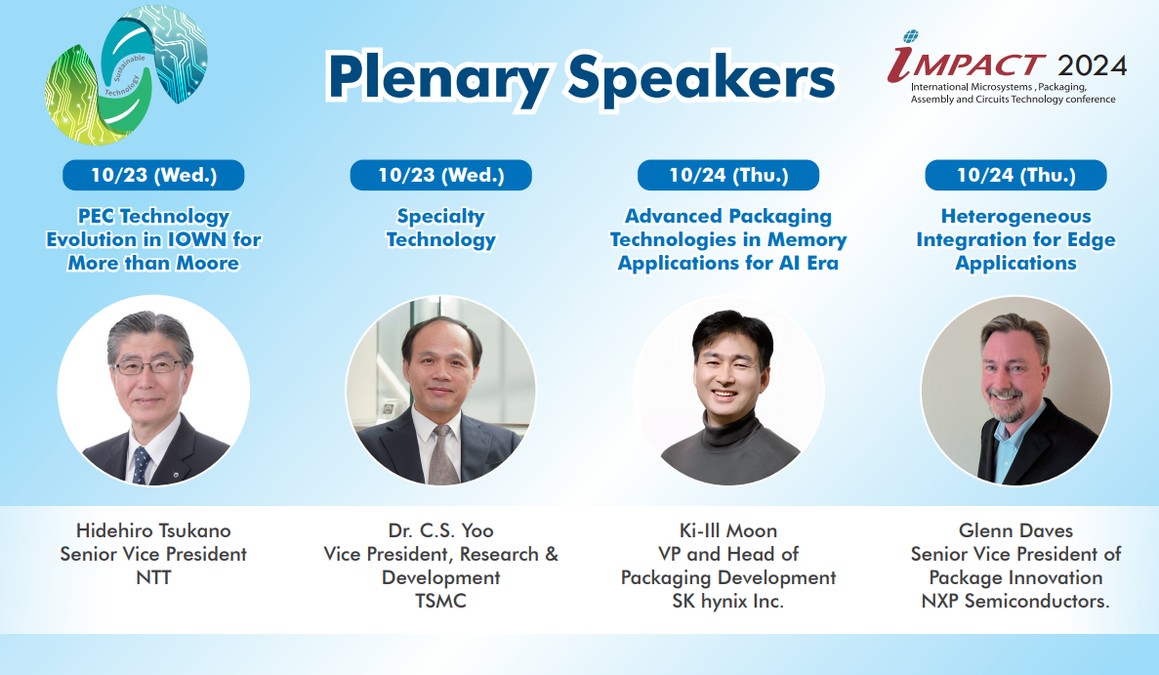
IMPACT 2024 Plenary Speakers

Paper statistics
Year | 2024 | 2023 | 2022 | 2021
Poster | 46(P38,B8) | 48(P25,B23) | 37(P23,B14) | 37(P-25,B-12)
Oral | 109 | 86 | 82 | 70
Invited | 56 | 73 | 37 | 46
Industrial | 29 | 19 | 33 | 19
Plenary | 4 | 4 | 5 | 5
Total | 244 | 230 | 194 | 177

Conference Attendee statistics

